## Table of Contents

**Table of Contents 1**

**Hub Connectivity 2**

**Switch Connect to Pc 3**

**Three Switches Connect to form one Network 3**

**Connect Two Switches with one router 4**

Configuration of the router when connected to only switch 4

**Two Routers Connected through Serial Port 5**

Configuration of Router when connected to another router and also switch 5

**Two Router Three Switches 6**

**Three Router Three Switches 7**

**Three Router Four Switches 7**

**VLAN (Virtual Local Area Network) 7**

Configuration of Switch when we create VLAN 8

**Inter VLAN Router on struck 9**

**VTP Protocol 9**

## 

## Hub Connectivity

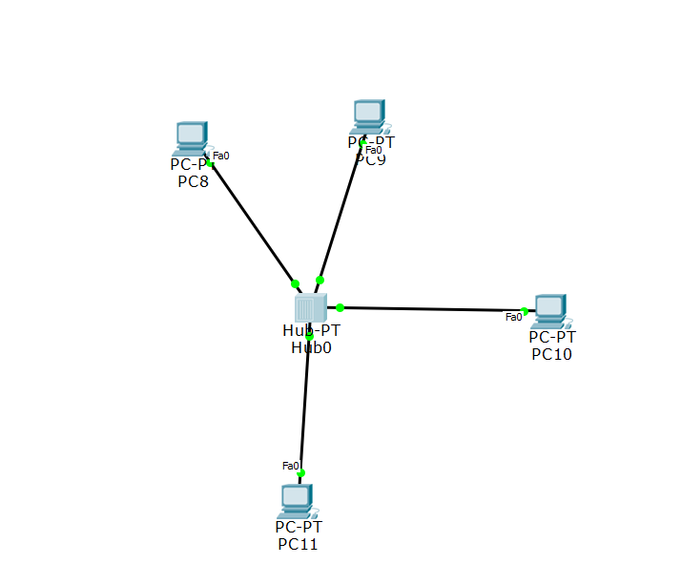

## Switch Connect to Pc

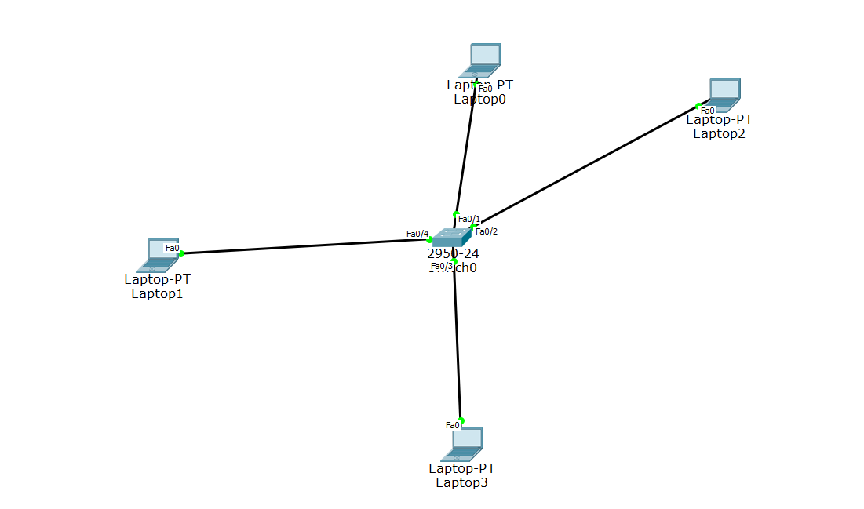

## Three Switches Connect to form one network

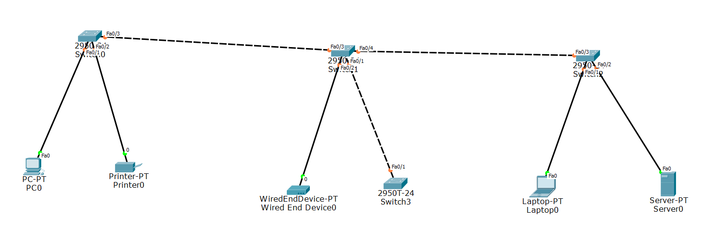

## Connect Two Switches with one router

### 

### Configuration of router when connected to only switch

First, go to the CLI option of router then

|  |
| --- |
| **Configuration**  Router>en  Router#confi t  Router (config) #int fastEthernet 0/0 (port number)  Router (config-if) #ip address 192.168.1.100 255.255.255.0  Router (config-if) #no shut //At that stage we see the message that  FastEthernet 0/0, changed state to up.  Router (config-if) #exit  Now we activate the next port from which another network is connected.  Router (config) # int fastEthernet 0/1 (Second port number)  Router (config-if) #ip address 192.168.2.100 255.255.255.0  Router (config-if) # no shut  Router (config-if) # exit  Now 2 different networks communicate with each other through router configuration. |

## Two Routers Connected through Serial Port

* **Data Communication Equipment (DCE)**

DCE is known to that router from which we start the wiring. At this router, you see the clock icon at that serial port we give the clock rate.

The clock rate specifies how many bits can be transmitted at a certain period. When the clock rate is set to 64000, you'll never be able to send more than 64 Kbps through the interface.

* **Data Terminal Equipment (DTE)**

DTE is known to that router which connects to the clock rate serial port

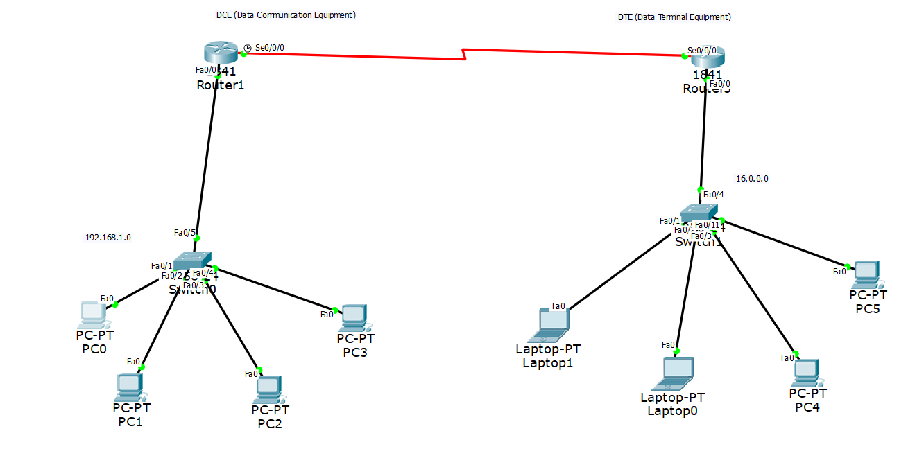

### Configuration of Router when connected to another router and also switch

|  |
| --- |
| **Configuration**  Router>en  Router# confi t  Router (config) # router rip  Router (config-router)# network 192.168.1.0  Router (config-router)# network 192.168.2.0 // we tell the router all the network  Which is connected to it.  Router (config-router)# exit  Router (config)# int serial 0/0/0 //Serial port on which another router is  Connected  Router (config-if)# clock rate 6400 //clock rate always given to serial  Port  Router (config-if)# ip address 192.168.2.1 255.255.255.0 //ip address of that router  Router (config-if)# no shut //Message of activate serial port state up  Router (config-if)# exit  Router (config)# int FastEthernet 0/0  Router (config-if)# ip address 192.168.1.100 255.255.255.0  Router (config-if)# no shut  Router (config-if)# exit |

* We also perform the same configuration on the second router, but the only difference is that we can’t give that router the clock rate.

## Two Router Three Switches

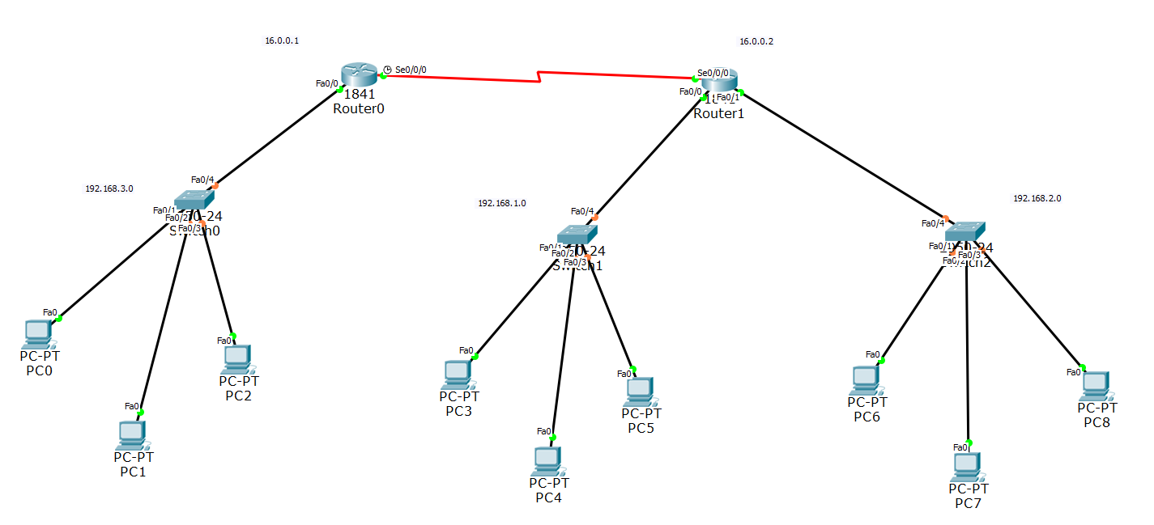

## Three Router Three Switches

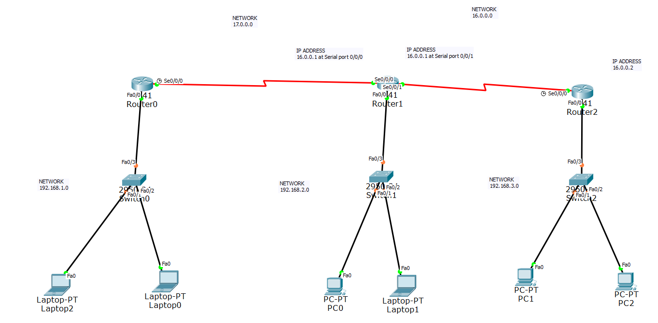

## Three Router Four Switches

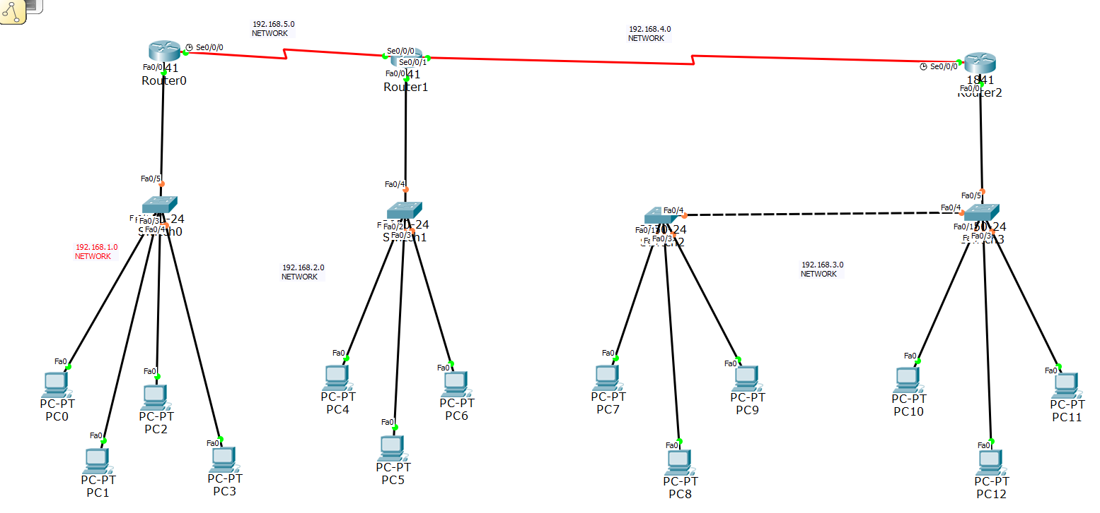

## VLAN (virtual Local Area Network)

Through VLAN we create multiple network on one switch. In this senerio I create three VLAN with different networks.

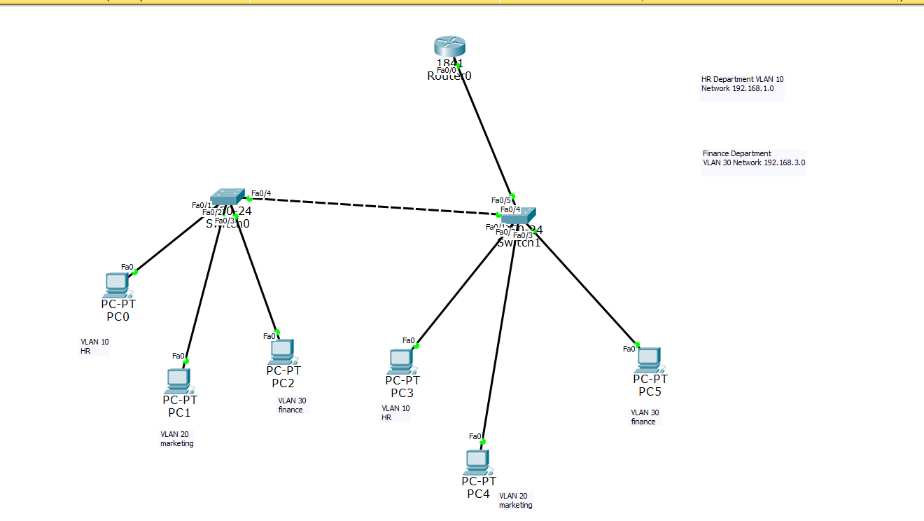

### Configuration of Switch when we create VLAN

|  |
| --- |
| **Configuration**  switch>en  switch>confi t  switch(config)#vlan 10 switch(config-vlan)# name HR  switch(config-vlan)#vlan 20  switch(config-vlan)#name Marketing  switch(config-vlan)#vlan 30  switch(config-vlan)#name France  switch(config-vlan)#exit  switch(config)#int Fastethernet 0/1  switch(config-if)#switchport mode access  switch(config-if)#switchport access vlan 10  switch(config-if)#exit  switch(config)#int Fastethernet 0/2  switch(config-if)#switchport mode access  switch(config-if)#switchport access vlan 20  switch(config-if)#exit  switch(config)#int Fastethernet 0/3  switch(config-if)#switchport mode access  switch(config-if)#switchport access vlan 30  switch(config-if)#exit  switch(config)#int Fastethernet 0/4 //change the mode port of switch to trunk  switch(config-if)#switchport mode trunk when it connects to another switch or  Router  switch(config-if)#exit  switch(config)#int Fastethernet 0/5  switch(config-if)#switchport mode trunk  switch(config-if)#exit |

## Inter VLAN Router on the stick

## 

Configuration of the router when we create VLAN

|  |
| --- |
| Configuration  Router>en  Router# confi t  Router(config)# int fastEthernet 0/0  Router(config-if)#no shut  Router(config-if)#exit  Router(config)# int fastEthernet0/0.0 //divide the port  Router(config-subif)# EncapulationDot1Q 10 //Encapsulation is the protocol used to  dedicate the sub port to VLAN 10  Router(config-subif)# ip address 192.168.1.100 255..255.255.0  Router(config-subif)#exit  Router(config)# int fastEthernet 0/0.1  Router(config-subif)# Encapsulation Dot1Q 20 //VLAN 20  Router(config-subif)# ip address 192.168.2.100 255.255.255.0  Router(config-subif)#exit  Router(config)# int fastEthernet 0/0.3  Router(config-subif)# Encapsulation Dot1Q 30 //VLAN 30  Router(config-subif)# ip address 192.168.3.100 255.255.255.0  Router(config-subif)#exit  Router(config)#exit |

## VTP Protocol

The VTP Protocol is used when we create the VLAN on many connected switches. Usually, we repeat the VLAN names on all switches, but we use the VTP Protocol instead.

We use the VTP Protocol to reduce the repetition and mistakes during repetition.

Three types of VTP Protocol

1. VTP mode server (main switch)
2. VTP mode Transparent (this mode doesn’t sync)
3. VTP mode Client (this mode syncs with the server switch)

We add and remove in the server and transparent mode but not in the client mode.

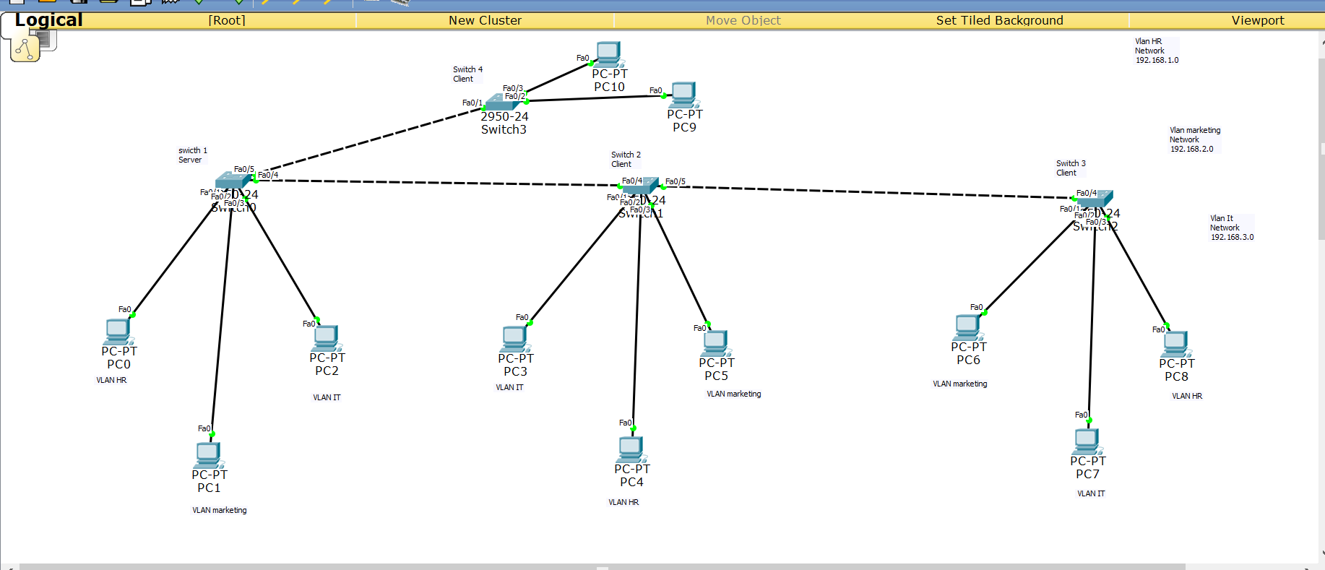

Thank You